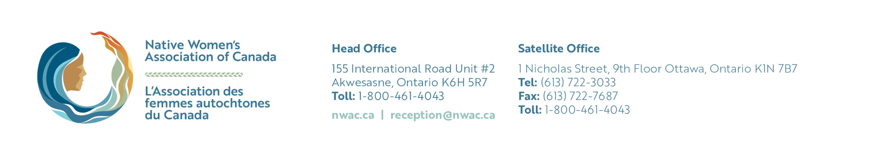

*Within this heart, you can write the actions you commit to doing to honour women, girls, and gender diverse people, that will contribute to systemic change to keep them safe.*

**#SISVigils**